INDUSTIAL ATTACHMENT REPORT UNDERTAKEN AT MASENO UNIVERSITY ICT DEPARTMENT FROM MAY 22ND TO AUGUST 22ND 2023



SUBMITTED BY:

NAME: RONNY OCHIENG OMONDI

CCS/00034/020

DATE OF SUBMISSION:25/8/2023

SUPERVISOR:

MR OUMA KONYINO

IN PARTIAL FULFILMENT OF THE REQUIREMENT FOR THE AWARD OF DEGREE OF BACHELOR OF SCIENCE IN COMPUTER SCIENCE

# DECLARATION

I RONNY OMONDI declare that this attachment report is my original work guided by the activities carried out during the attachment period in MASENO UNIVERISTY ICT DEPARTMENT. The report has not been submitted in any form at any institution/organization or for another degree or diploma at any university or other institute of tertiary education. I am therefore presenting it to the University of Maseno in the school of computing and informatics department of computer science for grading.

NAME: DATE: SIGNATURE

RONNY OMONDI …………. ……………….

# DEDICATION

This attachment report is dedicated to my parents, Mr. Samuel Agola and Mrs. Hellen Akinyi for the moral and financial support they have accorded me as I pursue my academic and career goals.

# ACKNOLEDGEMENT

The time I spent in ICT Department Maseno University as an attaché from May 2023 to August 2023 was a memorable one for me as it was rich in experience sharing and helped me discover my potential. I have had so many rich experiences and opportunities that I believe will forever shape and influence my professional life while fostering personal growth and development.

My attachment would not have been possible without the contribution and collaboration of others. My sincere gratitude to:

First, the almighty God who granted me health and long life, without which I could not have finished this attachment;

Second, the ICT department fraternity, I want to thank them for giving me the opportunity for an attachment in their department. They had the kindness to accept me in their department and guide me through attachment with advice and feedback despite their busy schedule;

Third, the technical staff officer, Mr. Patrick Miganda who was also my supervisor for his technical support and constant supervision which contributed immensely to my personal development. I also thank him for his guidance which was a remarkable force that enabled me to complete the attachment program. He helped and coached me during my attachment by giving me feedback and tips on how to handle and approach situations;

Fourth, my university assessor Mr. Ouma Konyino for being supportive and believing in me during the assessment and for the words of encouragement that I will forever treasure.

Last but not least, special thanks go to my family; my parents for supporting me both financially and morally throughout the period and my life in general.

God bless you all.

# EXECUTIVE SUMMARY

In fulfillment of the requirement of the Degree of science in Computer science at Maseno University of Kenya, it is mandatory for Third year second semester students to have a minimum of two months practical industrial experience in their respective fields of training and organization of their choice. An industrial attachment is essential requirement for awarding of Bachelor Degree Certificate in Maseno University of Kenya.

The purposes of the attachment are to prepare the student to serve needs of industry and information technology more effectively upon graduation. This included providing real life experience and exposure, thus gaining first-hand exposure of working in the real world, granting the opportunity to learn more about the attachment self-potentials and abilities, getting connected and developing professional network, preventing CV from going to trash during job application and transition to full-time job position. Attachment allows students to harness the skill, knowledge and theoretical practice they learned in the University and enabling them to transform theory into practical real-life situations.

Table of Contents

DECLARATION ii

DEDICATION iii

ACKNOLEDGEMENT iv

EXECUTIVE SUMMARY v

ABBREVIATIONS vii

CHAPTER 1: INTRODUCTION 1

1.1 Overview of the Industrial Attachment Exercise 1

1.2 History of the Organization 2

1.3 About the Organization 4

1.4 The Organization 5

1.5 Duties and Responsibilities of Key Personnel: 6

1.6 Contacts 9

CHAPTER 2: HOST ATTACHMENT DEPARTMENT 10

2.1 Department sections 10

2.4 Staff Establishment: 12

2.5 Attaché’s Assigned Routine Duties 13

2.6 Department's Participation Forum: 15

CHAPTER 3: EVALUATION OF THE ATTACHMENT PERIOD 16

3.1 Success of the attachment 16

3.2 Challenges 18

3.3 Overcoming Challenges 19

3.4 Recommendations 21

CONCLUSION 23

BIBLIOGRAPHY/ REFERENCES 24

APPENDICES 25

# ABBREVIATIONS

ICT- Information Communication and Technology

LAN- Local Area Network

WI-FI- Wireless Fidelity

IP- Internet Protocol

DNS- Domain Name Service

CMOS- Complementary Metal Oxide Semi-conductor

SEO- Search Engine Optimization

IT- Information Technology

WAN- Wide Area Network

PC- Personal Computer

# CHAPTER 1: INTRODUCTION

### 1.1 Overview of the Industrial Attachment Exercise

The industrial attachment exercise is a pivotal phase of academic programs at Maseno University, offering students the chance to apply classroom knowledge in real-world contexts. This practical experience enhances their skills, fosters professional growth, and prepares them for their future careers. The objective of the industrial attachment program generally includes the following:

1. To enhance industry’s satisfaction with the graduates of the faculty in particular and university at large therefore marketing the student as a potential in the job market.
2. To enlist and strengthen employers’ involvement in institutional activities and in the entire educational process of preparing the students for employment in industry.
3. To make the transition from school to the world of work smoothly and to enhance student contacts for job placement.
4. To be familiarized with the actual working conditions and the latest technology at the workplace and the corporate world.
5. To provide the students with an opportunity to apply knowledge in real work situations thereby closing gap between university work and the actual practice.
6. To equip one with knowledge and the regulations governing their profession in the work environment.
7. To learn how to manage time and handle priorities at work place and meeting deadlines as per the authority.
8. To expose the students to work methods not taught in the university and to provide access to products and equipment not normally available in the environment of the university.
9. To assess the interest of the student in the occupation he/she plans to undertake

### 1.2 History of the Organization

Maseno University founded in 1991, is the only university on the globe that lies along the Equator (00). It is one of the original seven universities in Kenya. Initially operated as a constituent college under Moi University. It gained its full university status in 2001, marking a significant milestone in its journey of academic excellence and growth. As part of its expansion and modernization efforts, the university recognized the increasing importance of technology in education and administration.

It has a number of campuses namely;

1. Main Campus situated in Maseno Township along Kisumu-Busia Road, 25 km from Kisumu City and approximately 400 km west of Nairobi the capital city of Kenya,
2. Maseno University Kisumu Campus
3. Odera Akang'o University branch in Siaya County
4. **eCampus.** – The eCampus of Maseno University is one of the latest innovations by Maseno University to facilitate online delivery of high-quality certificate, diploma and degree programmes to learners in various parts of the country, the east African Region and beyond the use of modern technology to not only realize equitable access to higher education through eLearning, but also improve the quality of educational experiences for our learners.

Maseno Main Campus is in Maseno Township 25km from Kisumu on the Busia road. The core activities and central administration of the University takes place on this Campus. The eCampus is one of the latest innovations by Maseno University to facilitate online delivery of high-quality certificate, diploma and degree programmes to learners in various parts of the country, the East African region and beyond. All programmes offered at the eCampus are primarily delivered through the internet, with students taking online examinations at the end of each Semester. Kisumu Campus is within the CBD of Kisumu City and is exclusively served by a spacious parking yard situated directly opposite Kisumu Hotel (Maseno University).

The University boasts of fourteen (14) Schools and an institute offering various degrees, diplomas and certificates.

Maseno University has established collaborations with universities and research institutions in Kenya and abroad in the following areas: exchange of staff, visiting professorships, fellowships, student exchange programmes, establishing centers of excellence and research, innovation and technology.

The chair of University Council is Professor Abdalla Naji Said

The current Vice- Chancellor is Professor Julius Omondi Nyabundi

### 1.3 About the Organization

The ICT department at Maseno University plays a vital role in facilitating and enhancing various academic and administrative processes through technology. Its functions encompass four key sections: Web Section, Network Section, System Administrator Section and End User Section.

- Web Section: This section is responsible for designing, developing, and maintaining the university's web presence. It ensures that the official website is not only informative but also user-friendly and responsive to evolving needs.

- Network Section: This section takes charge of managing the university's network infrastructure. This includes configuring and maintaining network devices, ensuring secure and seamless connectivity, and troubleshooting network-related issues.

- End User Section: The End User Section focuses on delivering technical support to the university's staff and students. It assists in troubleshooting software and hardware problems, offers guidance on technology usage, and contributes to enhancing the overall user experience.

-System Administration Section: System Administration section is responsible for managing and maintaining the overall IT infrastructure and systems within an organization. The system section is responsible for various aspects related to computer systems, servers, and software applications.

### 1.4 The Organization

**Vision**

The University of Excellence in discovery and dissemination of knowledge

**Mission**

To discover, harness, apply, disseminate and preserve knowledge for good of humanity.

**Core Values**

The organization's core values include:

* Integrity
* Quality
* Relevance
* Excellence

**Service Charter**

The department is committed to adhering to a service charter that outlines its service delivery standards, timelines, and customer engagement protocols.

**Organizational Structure**

The department's organizational structure encompasses the three sections, each led by Maseno University ICT director Mr. Cosmas responsible for overseeing the section's functions, projects, and personnel.

Maseno university ICT department

System admin section

Network section

End user section

Web section

### 1.5 Duties and Responsibilities of Key Personnel:

Within each section, key personnel play integral roles:

1. Web Section: in the web section we have web developers, web designers and web masters who are responsible for the following responsibilities in the department of ICT:

**Web developers**

* Writing code to create and maintain web applications, websites and online platforms.
* Collaborating with designers and other developers to implement website features and functionality.
* Ensuring the website’s technical performance, speed, and responsiveness.
* Debugging and troubleshooting website issues.
* Integrating third-party APIs and services.
* Staying updated with web development trends and technologies.

**Web designers**

* Creating visual designs and layouts for websites and web applications.
* Selecting color schemes, typography, and graphical elements to enhance user experience.
* Designing user interfaces that are intuitive and visually appealing.
* Collaborating with developers to ensure design feasibility and implementation.
* Creating responsive designs that work well on various devices and screen devices

**Webmasters**

* Managing and maintaining the university’s websites and online presence.
* Updating website content, including text, images, and multimedia.
* Ensuring the security and integrity of the websites, including regular backups.
* Monitoring website performance, uptime, and user experience.
* Managing domain names, hosting, and server configurations.
* Implementing SEO (Search Engine Optimization) strategies to improve website visibility.

1. Network Section: in this section we have network administrators and technicians who are responsible for the following responsibilities:

* Install, configure, and maintain network hardware (routers, switches, firewalls, etc.)
* Manage local area network (LAN) and wide area network (WAN) connectivity.
* Implement and manage network security measures (firewalls, access controls)
* Conduct security audits and vulnerability assessments.
* Assist users with network related issues and provide training.
* Monitor And optimize network performance and bandwidth usage.
* Maintain documentation of network configurations and procedures.
* Set up and manage network backup and disaster recovery solutions.
* Collaborate with vendors for equipment procurement and services.
* Troubleshoot network issues and respond to incidents.
* Stay updated on networking technologies and trends.

1. End User Section: in the end user section we have technical support personnel who is responsible for the following responsibilities:

* Technical assistance: providing technical support to end users, assisting them in resolving hardware, software or network-related issues.
* Troubleshooting: diagnosing and troubleshooting technical problems faced by end users, both remotely and in person.
* Issue resolution: resolving user-reported problems efficiently and effectively to minimize disruption in theory work.
* Software support: assisting users with software installations, updates, patches, and troubleshooting software-related problems.
* Hardware support: assisting users with hardware-related issues, such as printer malfunctions, computer hardware failures, and connectivity problems.
* User training: offering guidance and training to users on how to effectively use various software applications.
* Documentation: creating and maintaining documentation for frequently asked questions, troubleshooting steps, and user guides.
* Communication: effectively communicating with end users to gather information about issues, explain solutions, and provide status updates.
* Remote support: using remote desktop tools to access and troubleshoot user’s computers from a distance.
* Password resets: assisting users with password resets and account access issues.
* Security awareness: educating users about best practices for cybersecurity and data protection.
* Escalation: escalating complex technical issues to higher level support or specialized teams when necessary.
* Feedback collection: collecting feedback from users to identify areas of improvement in IT services and support.

1. System administrator

Key responsibilities of the system administrator include the following:

* Carry out systems analysis, design and program specifications in direct liaison with the users.
* Develop, implement and maintain system design projects.
* Ensure adherence to established performance and systems development and many other.

1. ICT Director:

The ICT Director is the overall head of the department and is responsible for strategic planning, decision-making, and overseeing all ICT-related activities within the university. The ICT Director provides leadership to the various sections, coordinates projects, manages resources, and ensures that the department's efforts align with the university's goals and technological advancements.

### 1.6 Contacts

You can reach Maseno University on their official social media as follows:

|  |  |
| --- | --- |
| **Telephone Number** | 0722203411, +25457351620, +25457351622 |
| **Facebook Pages** | Maseno University (http://www.facebook.com/MasenoUniversity) |
| eCampus Maseno University (http://www.facebook.com/MSU.eCampus) |
| **Twitter** **Handles** | @maseno_Uni |
| @maseno_eCampus |
| **Website** | https://maseno.ac.ke |
| **Gmail** | info@maseno.ac.ke |
|  |  |

# CHAPTER 2: HOST ATTACHMENT DEPARTMENT

In this chapter, we will delve into the host attachment department at Maseno University's ICT department. The department is organized into four key sections: End User Section, Network Section, System Administrator Section, and Web Section. We will explore the functions of each section, the staff establishment, the routine duties assigned to the attachment student, and the department's participation in forums.

### 2.1 Department sections

More detailed explanations of each section within the ICT department at Maseno university: the web section, the network section, and the end user section.

#### 2.1.1 web section

The web section is responsible for managing the university’s online presence and digital platforms. This involves creating, updating, and maintaining the official university website, as well as any web-based applications and services. Key roles and responsibilities of the web section include:

**Website development and design:** the web section designs and develops the university’s website to ensure it is visually appealing, user friendly, and aligned with the university’s branding and messaging.

**Content management:** The team manages and organizes the content published on the website, including information about academic programs, faculty, research, events, news, and more.

**User experience:**  The section focuses on providing an excellent user experience by optimizing navigation, layout, and accessibility of the website. This includes making sure the site is responsive and compatible across various devices.

**Web applications:** In addition to the main website, the web section may develop and maintain web-based applications that provide specific functionalities for students, faculty, and staff, such as online registration systems or student portals.

**Security and performance:** The team implements security measures to protect the website from cyber threats and ensures that it loads quickly and performs well for visitors.

#### 2.1.2 Network section

The network section focuses on building, maintaining, and securing the university’s computer networks, which are the backbone of communication and data exchange across the campus. Key responsibilities of the network section include:

**Network architecture:** The team designs the layout and structure of the university’s network, including the arrangement of routers, switches, and access points to ensure reliable and efficient connectivity.

**Configuration and monitoring:** Network specialists configure network devices and constantly monitor network traffic and performance to identify and address any issues promptly.

**Security infrastructure:** The network section implements security protocols, firewalls, intrusion detection systems, and other measures to safeguard the network from cyber threats and unauthorized access.

**Wireless connectivity:** The team sets up and manages wireless networks that allow students, faculty, and staff to access the internet and network resources from various locations on campus.

**Capacity planning:** Network specialists anticipate future growth and plan network expansions to accommodate the increasing demand for bandwidth and connectivity.

**Disaster recovery:** The section develops plans and strategies to recover the network quickly in case of network failures or data breaches.

#### 2.1.3 End user section

The end user support section is dedicated to assisting individuals within the university community who require technical help or guidance. The team ensures that users can effectively use technology for their academic and administrative tasks. Responsibilities of the end user support section include:

**Help desk support:** The team operates a help desk to receive and address user-reported issues, offering solutions and troubleshooting steps via phone, email, or in person interactions

**Problem resolution:** End user support specialists troubleshoot and resolve technical problems users encounter, ranging from software glitches to hardware malfunctions.

**Training and guidance:** The section provides training sessions and documentation to help users navigate software applications, tools, and online platforms used for academic and administrative purposes.

**User account management:** The team manages user accounts, permissions, and access to various systems and services, ensuring that users have appropriate level of access to resources.

**User satisfaction:** The section aims to maintain high levels of user satisfaction by delivering timely and effective support, thus contributing to a positive technology experience for all members of the university community.

### 2.4 Staff Establishment:

The department consists of a team of skilled professionals who collectively manage the ICT infrastructure of the university. The staff establishment includes network administrators, system analysts, web developers, technical support personnel, and administrative staff.

- Network Section: Comprises network administrators responsible for network design, configuration, security, and maintenance.

- Web Section: Encompasses web developers and content managers responsible for website design, development, and management.

- End User Section: Includes technical support personnel who assist users with hardware and software-related issues.

-System administrator section: Includes the System administrators

### 2.5 Attaché’s Assigned Routine Duties

As an attachment student in the ICT department, I was assigned a range of routine duties that aligned with my learning objectives and the department's functions. These duties included:

**Formatting and installation**

* Installation of antivirus software (Kaspersky Anti-virus 6.0) and updating it.
* Installation of operating system (windows 10).
* Installation of Microsoft office application program.
* Installation of browsers (chrome, Firefox, opera mini) and configuring it.
* Installation of printer and scanner drivers and updating.

**Hardware**

* Upgrading computers for example replacing CMOS battery and adding RAM
* Setting up a computer in a new location.
* Replacing faulty peripherals for instance keyboard mouse, monitors etc.
* Blowing of PC’s and printers and cleaning them.

-Here I used blowers in removing dust from desktop computers and printers from various offices within Maseno university.



Figure 1 DUST BLOWER

* Replacement of desktop power supply unit when faulty.
* Assembling and mounting of cabinets.
* Crimping ethernet cables.
* Configuring Ethernet cables connections.
* Replacing cartridges on printers.

Below find some of the computer hardware components that I interacted with during my attachment:



Figure 2 Desktop RAM

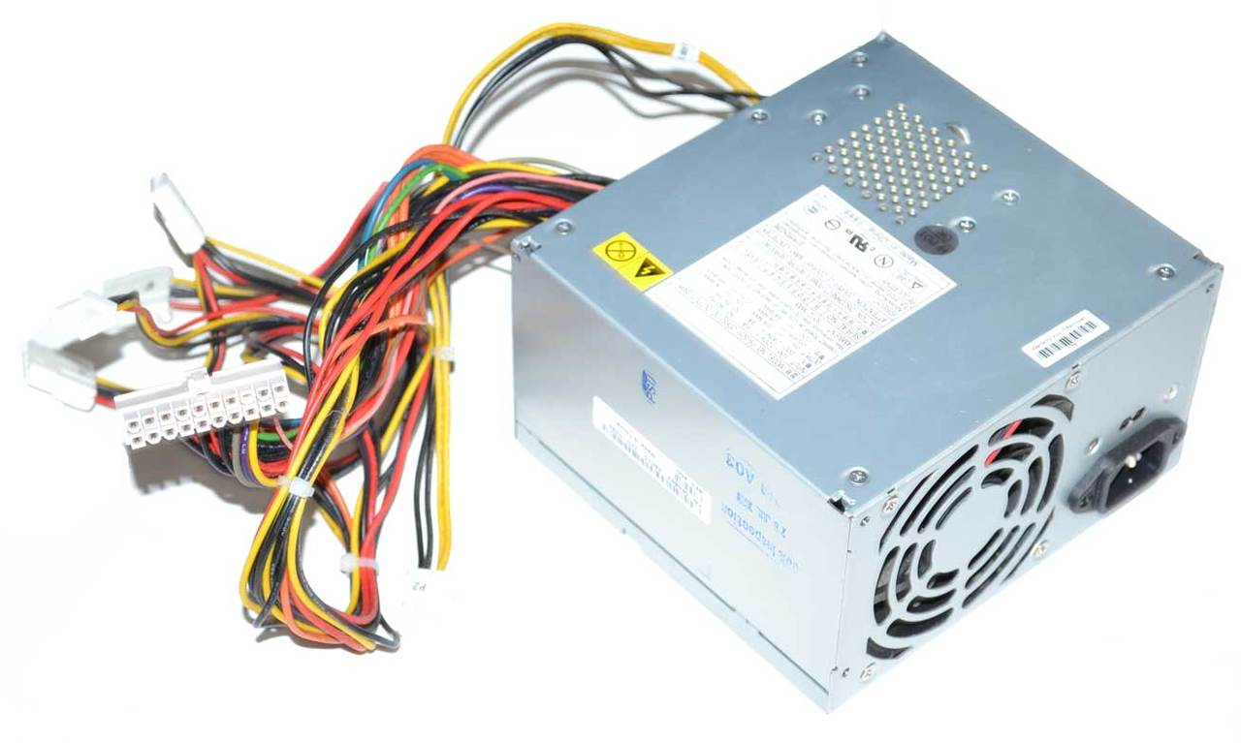

Figure 3 Power Supply Unit

**Help Desk**

* Providing support to users who have problems in network connections.
* Helping users with problem in receiving emails.
* Helping users with printer connection problems.
* Helping users to troubleshoot slow PC’s.
* Helping users in configuring WI-FI (eduroam).

### 2.6 Department's Participation Forum:

The department actively participates in various forums and activities to stay updated on ICT trends and share knowledge. These include:

- Internal Workshops: The department conducts workshops to enhance skills and knowledge among its members.

- Tech Seminars: Participation in technology seminars and conferences to stay informed about emerging trends and best practices.

- Interdepartmental Collaboration: Collaborating with other university departments to provide ICT solutions tailored to specific needs.

# CHAPTER 3: EVALUATION OF THE ATTACHMENT PERIOD

### 3.1 Success of the attachment

In evaluating the success of my industrial attachment period at Maseno University ICT department, I have experienced several positive outcomes. I was able to accomplish the objectives I set at the beginning of the attachment, which included gaining practical experience in various aspects of IT operations, enhancing my technical skills, and understanding theoretical applications of concepts learned in my academic coursework.

During my attachment, I actively participated in projects that allowed me to apply my theoretical knowledge to real-world scenarios. This hands-on experience enabled me to not only reinforce my understanding of IT concepts but also develop problem-solving skills and a deeper appreciation for the intricacies of IT systems.

Furthermore, the interactions with professionals at the university's ICT department provided me with valuable insights into the industry's best practices, trends, and challenges. Engaging in team discussions, collaborating on projects, and seeking guidance from experienced mentors greatly contributed to my personal and professional growth.

The primary goal of the attachment was to gain hands on experience in software development and project management, and I successfully accomplished this objective:

1. **Hardware troubleshooting and maintenance**

A significant aspect of the attachments’ success was my involvement in hardware troubleshooting and maintenance tasks. I successfully diagnosed and resolved hardware-related issues, ranging from malfunction components to network connectivity problems. These experiences not only showcased my technical proficiency but also affirmed my ability to apply theoretical knowledge in real world scenarios.

1. **Network configuration and management**

My success during the attachment is exemplified by my active participation in network configuration and management tasks. I gained practical exposure to setting up network devices, managing IP addresses, and ensuring seamless connectivity across various departments. This hands-on experience enhanced my understanding of network protocols and protocols.

1. **Collaborative projects**

Another indicator of success was my role in collaborative projects that required a deep understanding of computer hardware and network infrastructure. For instance, I actively participated in the setup of a network security simulation environment, contributing to the design and implementation of a network security measures. This project highlighted my ability to apply both theoretical and practical knowledge to address complex challenges.

1. **Skill enhancement**

The successful acquisition of skills relevant to computer hardware and networks is clear testament to the attachment’s accomplishment. I developed proficiency in configuring routers, switches, and firewalls, as well as gained insights into best practices for securing network environments. This skill enhancement underscores the alignment between the attachment’s objectives and my achievements.

1. **Problem solving in real time**

The ability to troubleshoot and address hardware and network issues in real time situations further validates the success of the attachment. Through quick and effective problem solving, I contributed to maintaining the operational integrity of the department’s IT infrastructure.

1. **Knowledge application**

The success of the attachment can be further seen in the effective application of theoretical knowledge acquired during academic studies. The transition from classroom learning to practical implementation was smooth, indicating a strong foundation in relevant concepts. This practical application reinforced my understanding of software development principles and methodologies.

### 3.2 Challenges

While my attachment period at Maseno University ICT department yielded valuable experiences and growth, it's important to acknowledge the challenges I encountered during this time. These challenges played a significant role in shaping my understanding and contributed to my personal and professional development.

**a. Network Configuration Complexity:**

One of the key challenges I faced was the complexity of network configuration and management tasks. Working with intricate network setups and addressing issues such as network congestion and intermittent connectivity proved to be more challenging than anticipated. These challenges occasionally led to delays in project timelines and required additional support and guidance.

**b. Hardware Compatibility Issues:**

Another notable challenge was encountered while troubleshooting hardware compatibility issues. Integrating new hardware components into existing systems sometimes resulted in unexpected conflicts and malfunctions. These challenges not only demanded additional time for resolution but also required collaboration with experienced colleagues for effective problem-solving.

**c. Overcoming Learning Curve:**

The adjustment to the department's specific coding standards, tools, and network protocols presented a substantial learning curve. This affected the speed at which I could contribute to ongoing projects initially, as I needed time to become acclimated to the established practices within the department.

**d.** **Limited Communication Breakdown:**

At certain points, miscommunication within the team led to misunderstandings regarding project requirements and priorities. This hindered the seamless coordination necessary for successful project execution, resulting in minor setbacks and the need for clarifications.

**e. Time Management Struggles:**

Balancing multiple tasks, including ongoing projects, learning new tools, and addressing unforeseen challenges, sometimes proved overwhelming. Struggles with time management led to instances where my focus was divided, potentially impacting the quality of my work.

### 3.3 Overcoming Challenges

Despite the challenges faced during my attachment period at Maseno University ICT department, I actively sought solutions and strategies to overcome these obstacles. The process of addressing these challenges provided invaluable lessons and insights that contributed to my personal and professional growth.

**a. Network Configuration Complexity:**

To address the challenge of complex network configurations, I took a proactive approach by seeking guidance from experienced network administrators within the department. I engaged in focused self-study to enhance my understanding of network protocols and troubleshooting techniques. By gradually breaking down complex configurations into smaller components and seeking help when needed, I was able to navigate and resolve network issues more effectively over time.

**b. Hardware Compatibility Issues:**

When encountering hardware compatibility issues, I learned the importance of thorough research and testing before implementing new hardware components. To overcome these challenges, I collaborated closely with hardware experts and engaged in meticulous testing before integrating new hardware. This proactive approach reduced the occurrence of compatibility issues and minimized disruption to ongoing projects.

**c. Overcoming Learning Curve:**

To overcome the learning curve associated with the department's coding standards and tools, I actively engaged in self-directed learning. I utilized online tutorials, documentation, and mentorship from senior developers to bridge the knowledge gap. By dedicating time to learning and practicing with the coding standards and tools, I was able to gradually align my work with the established practices of the department.

**d. Communication Breakdown Resolution:**

To address communication breakdowns, I initiated regular status update meetings with team members. These meetings provided a platform for clarifications, sharing project updates, and addressing any misunderstandings. The proactive communication approach improved team coordination and reduced the chances of misaligned expectations.

**e. Time Management Improvement:**

Recognizing the struggle with time management, I implemented time-tracking techniques and prioritization strategies. I created a detailed schedule that allocated time for ongoing projects, skill enhancement, and unforeseen challenges. This approach helped me allocate sufficient time to each task and enhance overall productivity.

### 3.4 Recommendations

Based on my experiences during the attachment period at Maseno University ICT department, I have identified several recommendations that could enhance the attachment exercise for future students. These recommendations aim to improve various aspects of the program and contribute to a more effective and fulfilling attachment experience.

**1. Practical Hardware Labs:**

Recommendation: Establish dedicated hardware labs equipped with a variety of computer components, peripherals, and diagnostic tools. Students should have hands-on access to assembling, disassembling, and troubleshooting hardware components to develop practical skills.

**2. Hardware Simulation Software:**

Recommendation: Integrate hardware simulation software that allows students to virtually design, build, and test computer hardware configurations. This approach provides a risk-free environment for experimentation and learning.

**3. Guided Hardware Projects:**

Recommendation: Include guided hardware projects that allow students to work on assembling and configuring computers, setting up local area networks, and troubleshooting common hardware issues. These projects should span various complexity levels to cater to students with different skill levels.

**6. Hardware Documentation:**

Recommendation: Develop comprehensive documentation and reference materials on hardware components, architectures, and compatibility considerations. Students should have access to up-to-date resources that aid in hardware understanding.

**7. Problem-Solving Workshops:**

Recommendation: Organize workshops that focus on diagnosing and troubleshooting hardware issues. These hands-on sessions should guide students through the process of identifying and resolving common hardware problems.

**8. Hardware Up gradation Projects:**

Recommendation: Include projects that involve upgrading existing computer systems to improve performance, add new features, or enhance efficiency. This practical experience will teach students about compatibility and optimization.

**9. Hardware Research Opportunities:**

Recommendation: Encourage students to engage in hardware-related research projects, such as investigating emerging hardware technologies, benchmarking performance, or analyzing hardware trends. Research opportunities can foster innovation and critical thinking.

**10. Collaborative Hardware Challenges:**

Recommendation: Organize collaborative challenges where students work in teams to solve complex hardware-related problems. These challenges can encourage teamwork, creativity, and a competitive spirit among students.

# CONCLUSION

The industrial attachment at Maseno University ICT Department has provided a transformative learning journey marked by significant growth and practical insights. Guided by dedicated mentors, I have acquired a comprehensive understanding of the ICT field, expanding my knowledge through hands-on projects and collaborative engagements within the department. The support of my supervisors and colleagues has been instrumental in shaping my experience. This attachment has not only enhanced my technical skills but also honed my adaptability in the face of challenges. As I conclude this period, I am equipped with practical expertise and a broader perspective, poised to contribute effectively to the dynamic realm of ICT.

# BIBLIOGRAPHY/ REFERENCES

During my industrial attachment, I drew insights from the following sources:

1. Hwang, K. (1992). Advanced Computer Architecture: Parallelism, Scalability, Programmability. Publisher.
2. Oka, M. M. (2012). Business Applications Of Computers (10th ed.). Everest.
3. Hayes, J. P. (2007). Computer Architecture & Organization (3rd ed.). MGH.
4. Ram, B. (2000). Computer Fundamentals: Architecture & Organization (4th ed.). New Age.
5. Oka, M. M. (2012). Business Applications Of Computers (7th rev ed.). Everest.
6. Dahiya, U., Nagpal, S. (2009). Computer Applications In Management. Taxman Allied Service.
7. Martin, J. (1997). Computer Data-base Organization (2nd ed.). PHI.
8. Goel, A. (2014). Computer Fundamentals. Pearson.

# APPENDICES

Appendix A: Screenshots

1: Service charter

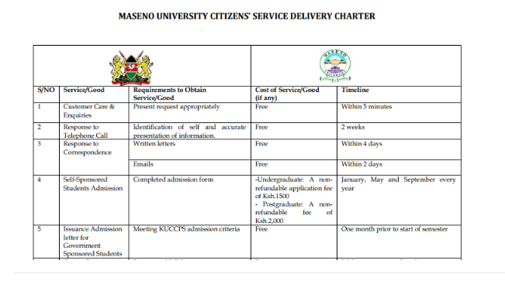

Appendix B: Relevant Information

- Network Configuration

Helping staff in configuring the network in their PC’s

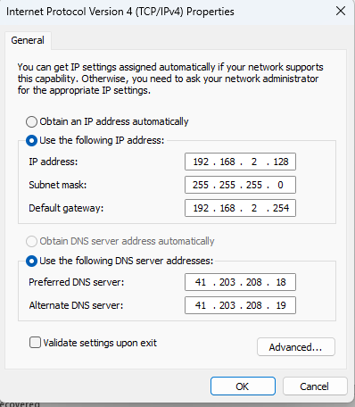

Appendix C: Glossary

- API: Application Programming Interface